GPS Assistance MN DNRGarmin GPS Tool

Installation

- Go to http://www.dnr.state.mn.us/mis/gis/tools/arcview/extensions/DNRGarmin/DNRGarmin.html
- Scroll down to “Download Program” and click on DNRGarmin 5.3.2.
- A screen will prompt you, “Do you want to run or save this file?” Click SAVE.
- Next in the SAVE AS window, select SAVE IN: desktop. Then click SAVE in the bottom right.
- When download is complete, close web browser and all other programs.
- Double click on dnrgarminsetup file (you may have to unzip). Double click on dnrgarminsetu53.exe to begin installation. Click next when file location is prompted, accept user license, and complete installation by clicking finish. Now you should have a DNR Garmin shortcut on your desktop.

Uploading tracks and waypoints to the GPS

*** Most Garmin GPS Units will work without any settings being changed.

- Create a folder on your desktop titled My CFC GPS.
- Download CFC boundary file from our website or received by email and save to My CFC GPS.
- Turn GPS unit on (Select Menu: Use GPS without satellites).
- Set Datum and Projection on your GPS unit by navigating in your menu system to system setup: select UTM NAD 83
- Connect your GPS unit to your computer via the USB or serial cable.
  - If this is the first time, your computer will display a message bubble “Found New Hardware.” Click the bubble and follow the wizard instructions to install the device driver. Your computer needs the device driver to properly communicate with the computer. During the “Found New Hardware” wizard, insert your CD-ROM that came with your unit and identify the folder labeled Device Driver (label of folder may vary by model, but your CD-ROM should have a device driver folder). Proceed with installation. (If you do not have the cd-rom that was included with your gps, we may be able to assist you with device drivers, or they can be downloaded from the manufacturers web-site.)
- Open DNR Garmin.
- Select “File” → “Set Projection”
- Match projection settings as seen below. 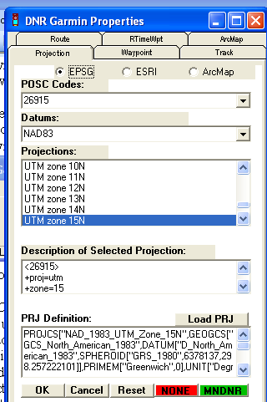
- Select “GPS” → “Set port” (select type of port). If using a serial connection instead of a USB, “Set Baud Rate” should be checked at 9,600 (Garmin default). * NOTE: this will only have to be done the first time you use DNR Garmin.
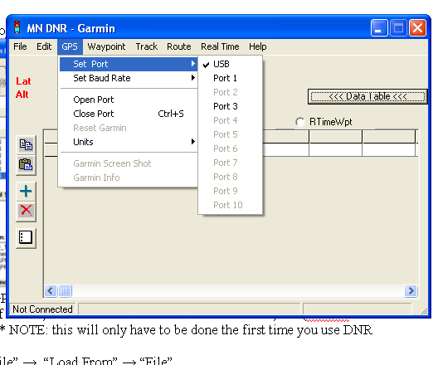
- Select “File” → “Load From” → “File”
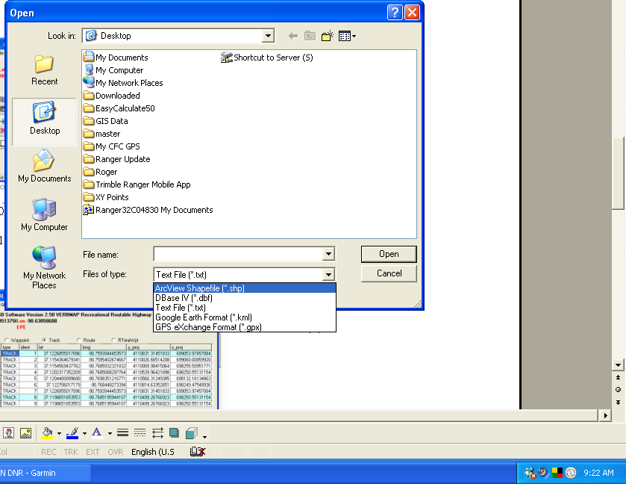
- On the bottom of the OPEN window, change the “Files of Type” box to “ArcView Shapefile (*.shp)”. Make sure that the OPEN window is looking in the My CFC GPS that contains the boundary file you want to upload to your GPS.
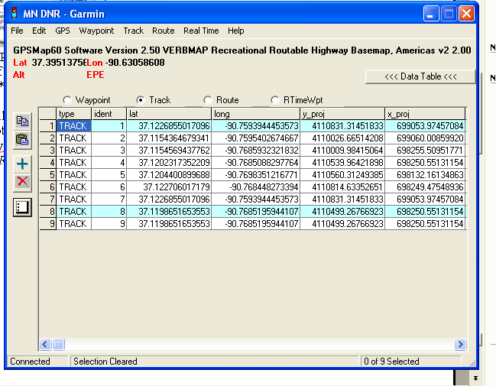

(A)

(B)

- If the individual tracks are not shown, click the data table button. (A)
- Select all tracks by clicking the grey numbers on the left side of the data table. (B)
- Select “Track” → “Upload”. When the “Transfer Complete” dialogue box appears, click “OK”. The track is on your GPS. If you are uploading waypoints be sure to select “Waypoints”, and use the waypoints drop down menu.
- ***Note: This following step is on your GPS handheld, not your computer. At the main menu of your GPS, highlight “Tracks” and press “Enter”. Highlight “Save” and press enter. If desired, you can re-name the track, or just leave it as the current date. Make sure the box labeled “Show on Map” is checked, so the track will display on the GPS screen.

If you have a problem, call us at 573-223-7010 and we will try to assist in any way we can.

